**VIRTUAL ART GALLERY SHEMA DDL AND DML**

CREATE THE ARTISTS TABLE

CREATE TABLE Artists (

ArtistID INT PRIMARY KEY,

Name VARCHAR(255) NOT NULL,

Biography TEXT,

Nationality VARCHAR(100)

);

CREATE THE CATEGORIES TABLE

CREATE TABLE Categories (

CategoryID INT PRIMARY KEY,

Name VARCHAR(100) NOT NULL

);

CREATE THE ARTWORKS TABLE

CREATE TABLE Artworks (

ArtworkID INT PRIMARY KEY,

Title VARCHAR(255) NOT NULL,

ArtistID INT,

CategoryID INT,

Year INT,

Description TEXT,

ImageURL VARCHAR(255),

FOREIGN KEY (ArtistID) REFERENCES Artists (ArtistID),

FOREIGN KEY (CategoryID) REFERENCES Categories (CategoryID)

);

CREATE THE EXHIBITIONS TABLE

CREATE TABLE Exhibitions (

ExhibitionID INT PRIMARY KEY,

Title VARCHAR(255) NOT NULL,

StartDate DATE,

EndDate DATE,

Description TEXT

);

CREATE THE EXHIBITIONARTWORKS TABLE (ASSOCIATION TABLE)

CREATE TABLE ExhibitionArtworks (

ExhibitionID INT,

ArtworkID INT,

PRIMARY KEY (ExhibitionID, ArtworkID),

FOREIGN KEY (ExhibitionID) REFERENCES Exhibitions (ExhibitionID),

FOREIGN KEY (ArtworkID) REFERENCES Artworks (ArtworkID)

);

INSERT DATA INTO ARTISTS

INSERT INTO Artists (ArtistID, Name, Biography, Nationality) VALUES

(1, 'Pablo Picasso', 'Renowned Spanish painter and sculptor.', 'Spanish'),

(2, 'Vincent van Gogh', 'Dutch post-impressionist painter.', 'Dutch'),

(3, 'Leonardo da Vinci', 'Italian polymath of the Renaissance.', 'Italian');

INSERT DATA INTO CATEGORIES

INSERT INTO Categories (CategoryID, Name) VALUES

(1, 'Painting'),

(2, 'Sculpture'),

(3, 'Photography');

INSERT DATA INTO ARTWORKS

INSERT INTO Artworks (ArtworkID, Title, ArtistID, CategoryID, Year, Description, ImageURL) VALUES

(1, 'Starry Night', 2, 1, 1889, 'A famous painting by Vincent van Gogh.', 'starry_night.jpg'),

(2, 'Mona Lisa', 3, 1, 1503, 'The iconic portrait by Leonardo da Vinci.', 'mona_lisa.jpg'),

(3, 'Guernica', 1, 1, 1937, 'Pablo Picasso''s powerful anti-war mural.', 'guernica.jpg');

INSERT DATA INTO EXHIBITIONS

INSERT INTO Exhibitions (ExhibitionID, Title, StartDate, EndDate, Description) VALUES

(1, 'Modern Art Masterpieces', '2023-01-01', '2023-03-01', 'A collection of modern art masterpieces.'),

(2, 'Renaissance Art', '2023-04-01', '2023-06-01', 'A showcase of Renaissance art treasures.');

INSERT DATA INTO EXHIBITIONARTWORKS

INSERT INTO ExhibitionArtworks (ExhibitionID, ArtworkID) VALUES

(1, 1),

(1, 2),

(1, 3),

(2, 2);

1.Retrieve the names of all artists along with the number of artworks they have in the gallery, and list them in descending order of the number of artworks.

SELECT A.Name, COUNT(AR.ArtworkID) AS ArtworkCount

FROM Artists A

JOIN Artworks AR ON A.ArtistID = AR.ArtistID

GROUP BY A.Name

ORDER BY ArtworkCount DESC;

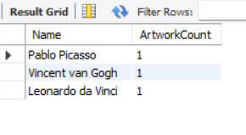

2.List the titles of artworks created by artists from 'Spanish' and 'Dutch' nationalities, and order them by the year in ascending order.

SELECT AR.Title

FROM Artworks AR

JOIN Artists A ON AR.ArtistID = A.ArtistID

WHERE A.Nationality IN ('Spanish', 'Dutch')

ORDER BY AR.Year ASC;

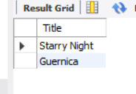

3.Find the names of all artists who have artworks in the 'Painting' category, and the number of artworks they have in this category.

SELECT A.Name, COUNT(*) AS ArtworkCount

FROM Artists A

JOIN Artworks AR ON A.ArtistID = AR.ArtistID

JOIN Categories C ON AR.CategoryID = C.CategoryID

WHERE C.Name = 'Painting'

GROUP BY A.Name;

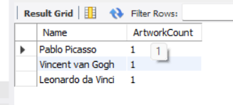

4.List the names of artworks from the 'Modern Art Masterpieces' exhibition, along with their artists and categories.

SELECT AR.Title, A.Name AS ArtistName, C.Name AS CategoryName

FROM ExhibitionArtworks EA

JOIN Artworks AR ON EA.ArtworkID = AR.ArtworkID

JOIN Artists A ON AR.ArtistID = A.ArtistID

JOIN Categories C ON AR.CategoryID = C.CategoryID

JOIN Exhibitions E ON EA.ExhibitionID = E.ExhibitionID

WHERE E.Title = 'Modern Art Masterpieces';

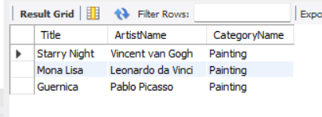

5.Find the artists who have more than two artworks in the gallery.

SELECT A.Name, COUNT(AR.ArtworkID) AS ArtworkCount

FROM Artists A

JOIN Artworks AR ON A.ArtistID = AR.ArtistID

GROUP BY A.Name

HAVING COUNT(AR.ArtworkID) > 2;

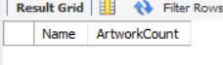

6.Find the titles of artworks that were exhibited in both 'Modern Art Masterpieces' and 'Renaissance Art' exhibitions

SELECT AR.Title

FROM Artworks AR

JOIN ExhibitionArtworks EA1 ON AR.ArtworkID = EA1.ArtworkID

JOIN ExhibitionArtworks EA2 ON AR.ArtworkID = EA2.ArtworkID

WHERE EA1.ExhibitionID = 1 AND EA2.ExhibitionID = 2;

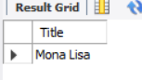

7.Find the total number of artworks in each category

SELECT C.Name AS CategoryName, COUNT(*) AS TotalArtworks

FROM Categories C

JOIN Artworks AR ON C.CategoryID = AR.CategoryID

GROUP BY C.Name;

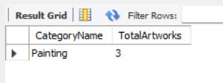

8.List artists who have more than 3 artworks in the gallery.

SELECT A.Name, COUNT(AR.ArtworkID) AS ArtworkCount

FROM Artists A

JOIN Artworks AR ON A.ArtistID = AR.ArtistID

GROUP BY A.Name

HAVING COUNT(AR.ArtworkID) > 3;

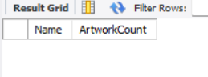

9.Find the artworks created by artists from a specific nationality (e.g., Spanish).

SELECT AR.*

FROM Artworks AR

JOIN Artists A ON AR.ArtistID = A.ArtistID

WHERE A.Nationality = 'Spanish';

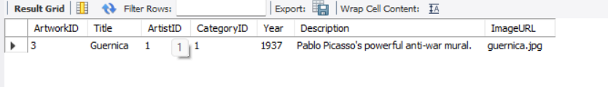

10. List exhibitions that feature artwork by both Vincent van Gogh and Leonardo da Vinci.

SELECT DISTINCT E.Title

FROM Exhibitions E

JOIN ExhibitionArtworks EA ON E.ExhibitionID = EA.ExhibitionID

JOIN Artworks AR ON EA.ArtworkID = AR.ArtworkID

JOIN Artists A ON AR.ArtistID = A.ArtistID

WHERE A.Name = 'Vincent van Gogh' OR A.Name = 'Leonardo da Vinci'

GROUP BY E.Title

HAVING COUNT(DISTINCT A.Name) = 2;



11.Find all the artworks that have not been included in any exhibition.

SELECT AR.Title

FROM Artworks AR

LEFT JOIN ExhibitionArtworks EA ON AR.ArtworkID = EA.ArtworkID

WHERE EA.ExhibitionID IS NULL;



12.List artists who have created artworks in all available categories.

SELECT A.Name

FROM Artists A

JOIN Artworks AR ON A.ArtistID = AR.ArtistID

GROUP BY A.Name

HAVING COUNT(DISTINCT AR.CategoryID) = (SELECT COUNT(*) FROM Categories);



13.List the total number of artworks in each category.

SELECT C.Name AS CategoryName, COUNT(*) AS TotalArtworks

FROM Categories C

JOIN Artworks AR ON C.CategoryID = AR.CategoryID

GROUP BY C.Name;

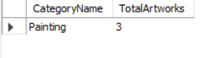

14.Find the artists who have more than 2 artworks in the gallery.

SELECT A.Name, COUNT(AR.ArtworkID) AS ArtworkCount

FROM Artists A

JOIN Artworks AR ON A.ArtistID = AR.ArtistID

GROUP BY A.Name

HAVING COUNT(AR.ArtworkID) > 2;

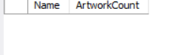

15. List the categories with the average year of artworks they contain, only for categories with more than 1 artwork.

SELECT C.Name, AVG(AR.Year) AS AverageYear

FROM Categories C

JOIN Artworks AR ON C.CategoryID = AR.CategoryID

GROUP BY C.Name

HAVING COUNT(AR.ArtworkID) > 1;

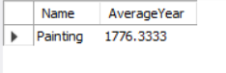

16. Find the artworks that were exhibited in the 'Modern Art Masterpieces' exhibition.

SELECT AR.*

FROM Artworks AR

JOIN ExhibitionArtworks EA ON AR.ArtworkID = EA.ArtworkID

JOIN Exhibitions E ON EA.ExhibitionID = E.ExhibitionID

WHERE E.Title = 'Modern Art Masterpieces';

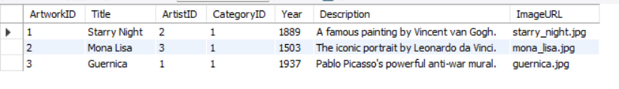

17.Find the categories where the average year of artworks is greater than the average year of all artworks.

SELECT C.Name

FROM Categories C

JOIN Artworks AR ON C.CategoryID = AR.CategoryID

GROUP BY C.Name

HAVING AVG(AR.Year) > (SELECT AVG(Year) FROM Artworks);



18.List the artworks that were not exhibited in any exhibition.

SELECT AR.Title

FROM Artworks AR

LEFT JOIN ExhibitionArtworks EA ON AR.ArtworkID = EA.ArtworkID

WHERE EA.ExhibitionID IS NULL;



19. Show artists who have artworks in the same category as "Mona Lisa."

SELECT DISTINCT A.Name

FROM Artists A

JOIN Artworks AR1 ON A.ArtistID = AR1.ArtistID

WHERE AR1.CategoryID = (

SELECT CategoryID FROM Artworks WHERE Title = 'Mona Lisa'

);

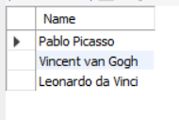

20.List the names of artists and the number of artworks they have in the gallery.

SELECT A.Name, COUNT(AR.ArtworkID) AS ArtworkCount

FROM Artists A

JOIN Artworks AR ON A.ArtistID = AR.ArtistID

GROUP BY A.Name;

